** *Orthogonaliy in space.***

**N.B.:**

• 3 points not aligned determine a single plane.

Example: × A



× B × C

• A point A and a line (d), such that A is outside the line (d), determine a single plane.

Example: A ×



(d)

• 2 parallel lines (d) and (d’) determine a single plane.

Example: (d)

(d’)

• Regular tetrahedron

A

B C AB=AC=AD=BC=BD=DC

D

6 stops: [AB];[AD];[AC];

[BC];[DC];[BD]

4 summits: A;B;C;D

4 figures : ABC; ACD; ABD; BCD

* 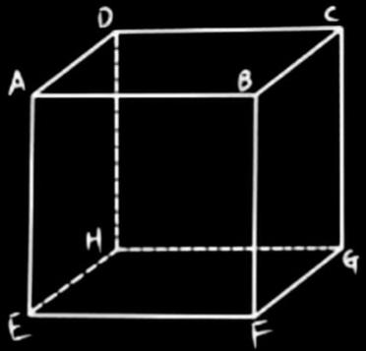Cube

12 stops:

AB=BC=CD=AD=AE=EF

=FG=GH=HD=HE=FB

6 figures are squares :

ABCD;EFGH;AEHD;

BFGC;HDCG;ABEF

1. summits: A;B;C;D;E;F;G;

* AF is perpendicular to EB
* FH is diagonal, perpendicular to EG and ED diagonal

**Positions of 2 lines in space.**

* 2 intersecting lines meet at 1 point.
* 2 parallel lines never meet.
* 2 lines are neither intersecting nor parallel.
* 2 lines coincide. ( فوق بعضهم)
* 2 coplanar lines <==> 2 lines lie in the same plane.
* If the angle between 2 lines = 90°, then they are orthogonal.
* A line is perpendicular to the plane (P), if and only if the line is perpendicular to 2 intersecting lines in the plane (P).